Viewport

Website Testing



**Bug Reporting Document**

Website Link:<https://viewportinc.com/>

Generic Issues:  
There is an overflow from the right side of website (from mobile till desktop screens)

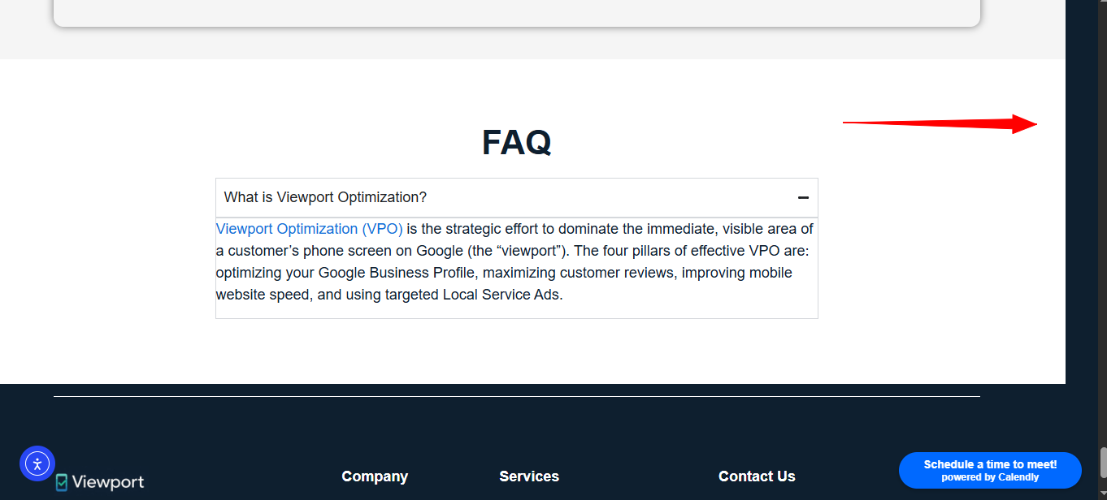

The Header on Mobile needs to have padding from left and right

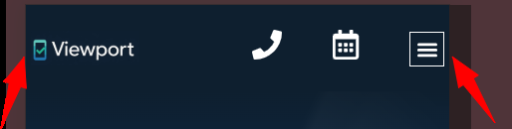

On Mobile, The Icon sizes and site logo size is not uniform. (Either make logo bigger (Preferable) + adjust icon to have comparatively smaller sizes so they can match the size consistency with the logo



The Header icons need to move toward right side a little bit and need the horizontal spacing in between them also needs to be reduced



The Hamburger menu needs to have padding from bottom on Mobile view

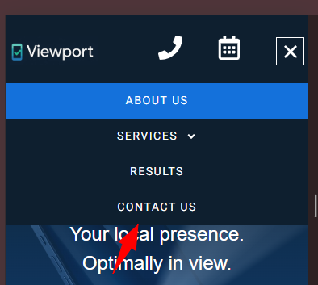

These highlighted sub-links of “Services” needs to have comparatively lower font-size as they are the sub-linking

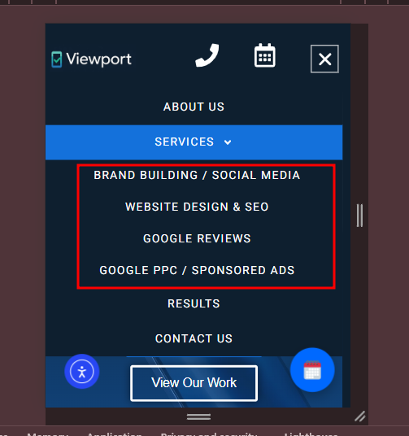

Hero Section of desktop version contain the following issues:  
1. Heading size needs to be adjusted  
2. Spacing between the hero section heading and sub-heading needs to be adjusted  
3. The Content is going out of the container (as indicated by a vertical line)  
4. CTA’s needs to have less horizontal spacing in between   
5. Overall Hero section size needs to be reduced (by reducing above spaces)  
**These changes must be done on the hero sections throughout the site + on all desktop screens**

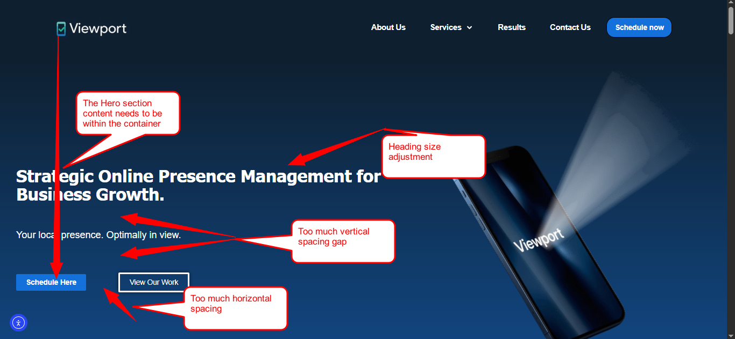

**Expected Result**

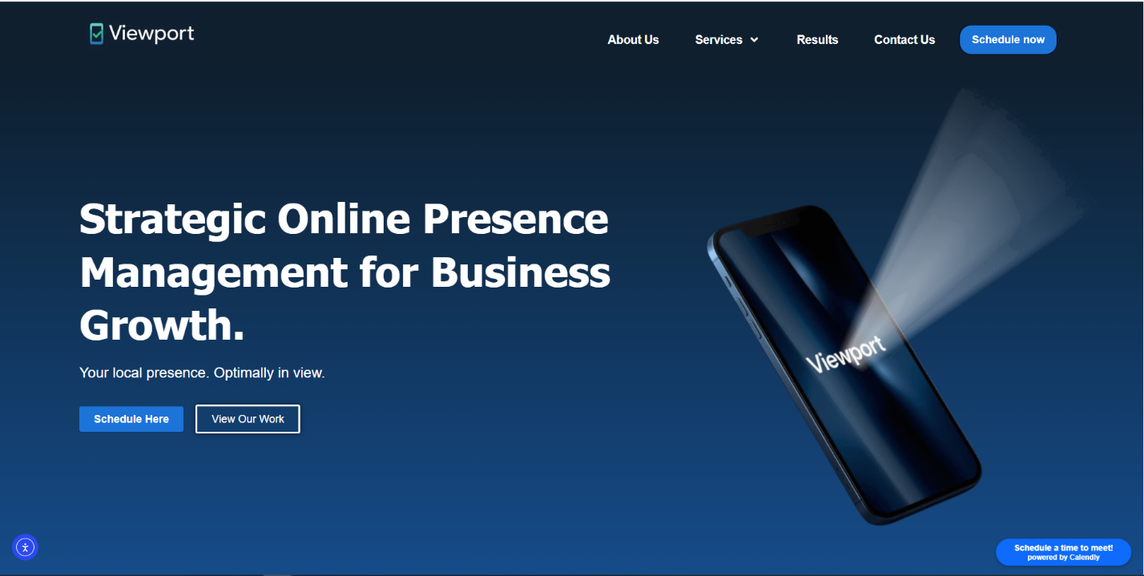

The hero section contains excessive spacing on top and bottom on both iPhone and Android devices (The same issue does also exist on the hero section of other pages and must be fixed for all)

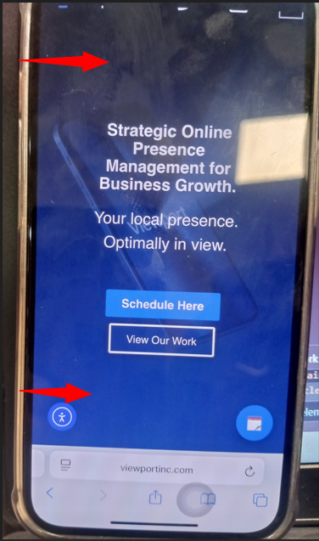

Hero Section of on mobile version contain the following issues:  
1. Heading sizes on mobile seems smaller   
2. Sub-text size on mobile seems to be way to bigger   
3. The vertical in-between spacing between the heading and sub-heading seems higher   
  
**Note: The changes must be catered from mobile till large tablet design (1024px)**  
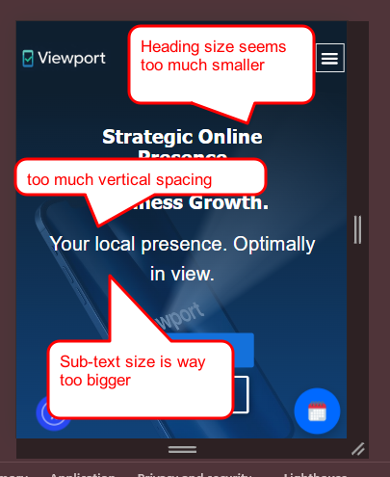

On Mobile, there is too much vertical spaces between each bullet point + he arrows icon on mobile looks way too bigger

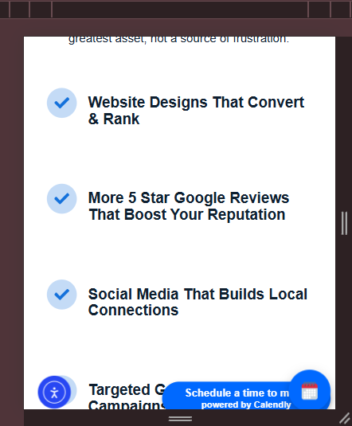

Section bottom spacing (padding) is way higher than that of top spacing + this following thing needs to be also catered on mobile

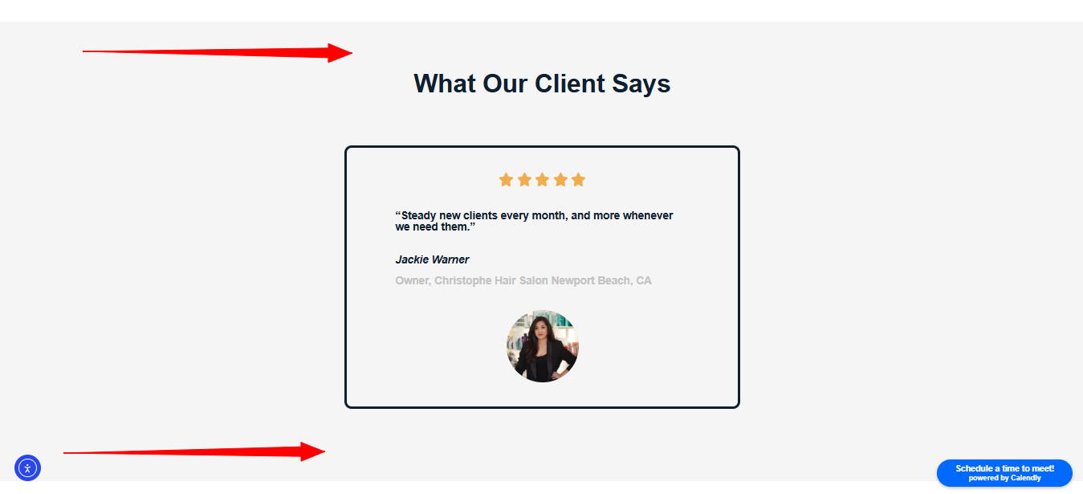

The Text within the box would have the “center” alignment text adjustment

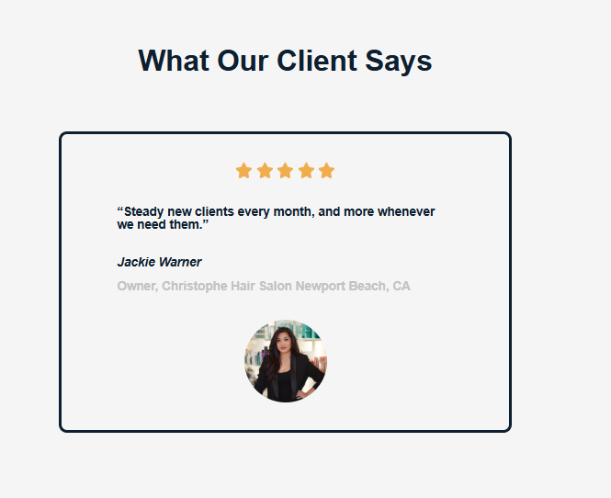

The Text within the box would have the “center” alignment text adjustment

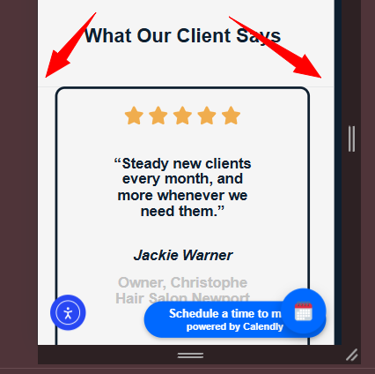

The heading can be in one single line (On large desktop screens such as 1920px) which would make all the text block appearing cleaner and more equal. (**Suggestion:** Similarly, increasing their horizontal spacing might also improve the visual readability)

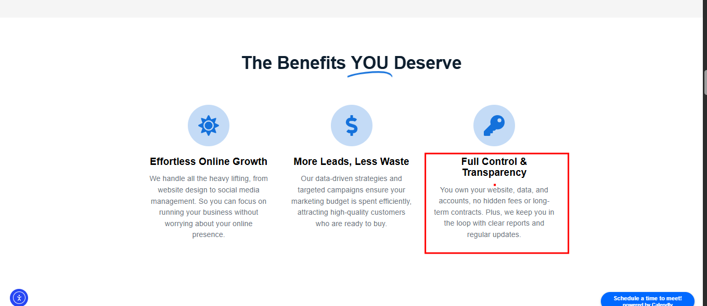

On Mobile, A little vertical spacing is required after each “Point” in order to enhance readability

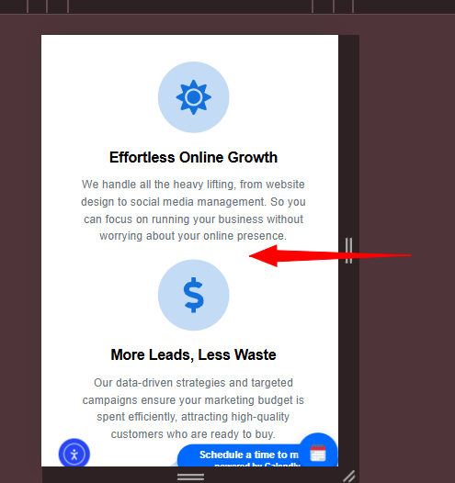

The Following issues needs to be resolved:  
1) First card “Social Media” font weight is different from other cards text   
2) The height of each card’s needs be equal and unform in size.

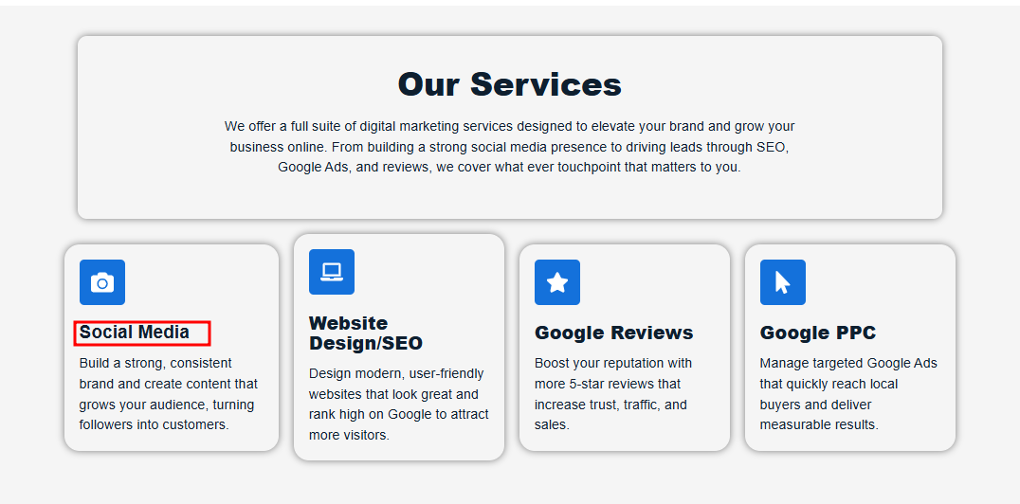

The vertical spacing between each of the cards seems pretty much on mobile, making the section vertically way longer

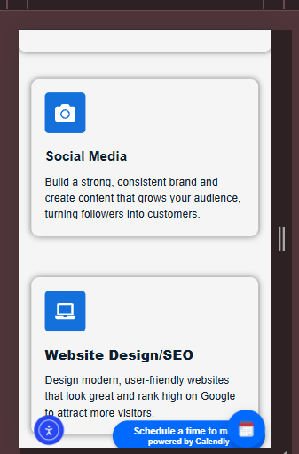

Our Services card on mobile will not go edge to edge on mobile (It will be either reduced or border will be removed on mobile) + The padding from the top of the section will be increased a little more



The vertical spacing between different portion of texts needs to be reduced

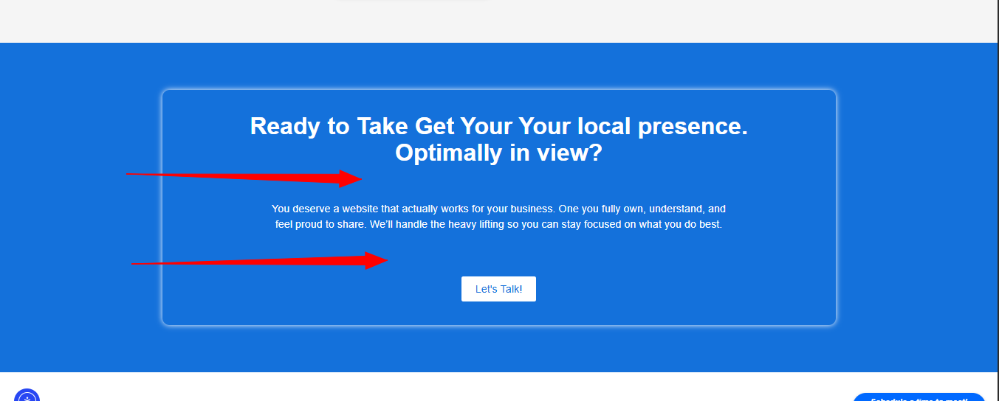

On Mobile, there is some spacing between and left and right side of the text which also needs to be covered with the text content

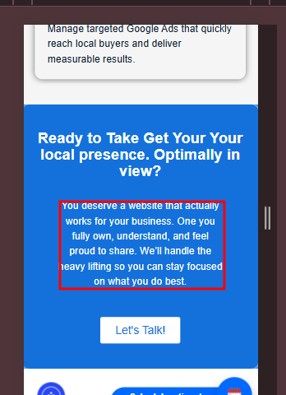

On Mobile, there is some unusual blue effect on the edges of the borders

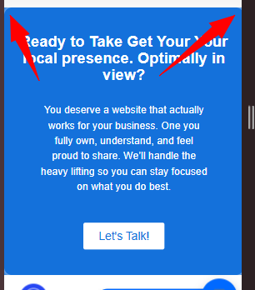

On Mobile, the line above the section needs to be removed (As the line will be removed, the vertical space would also be minimized)

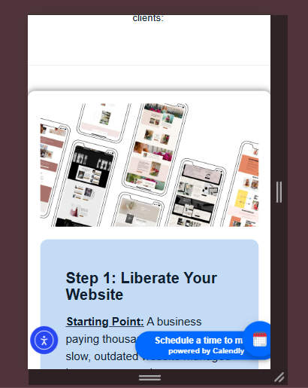

On Mobile, “Ready to Grow” section will not be edge to edge

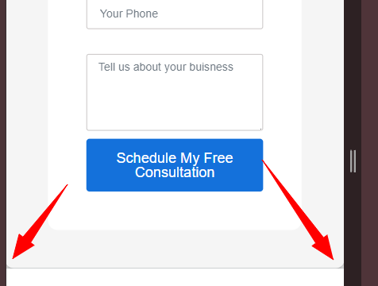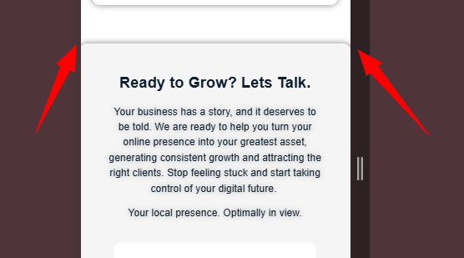

On both desktop and mobile, the text contains some drop shadow

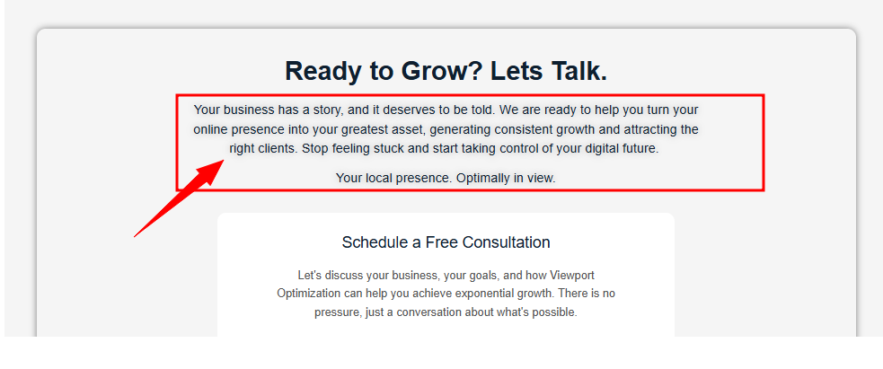

The Form submission message will be justified as “center” on both desktop and mobile

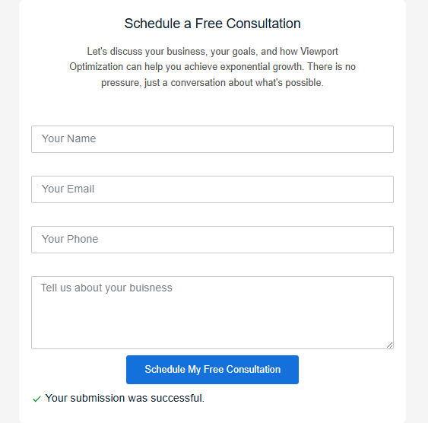

On Mobile, the font-size of CTA is way too bigger due to which CTA is also looking gigantic

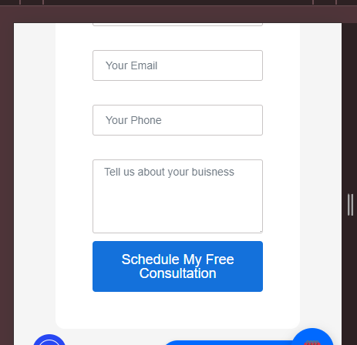

There is a need to add padding on left side on both mobile and desktop

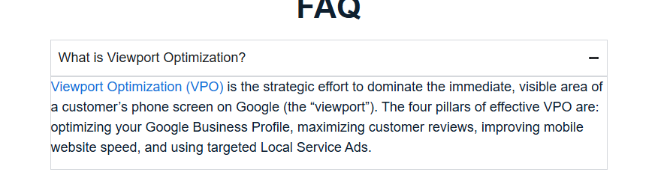

On Mobile, FAQ box seems too much vertically squeezed. + the blue heading size would also be reduced

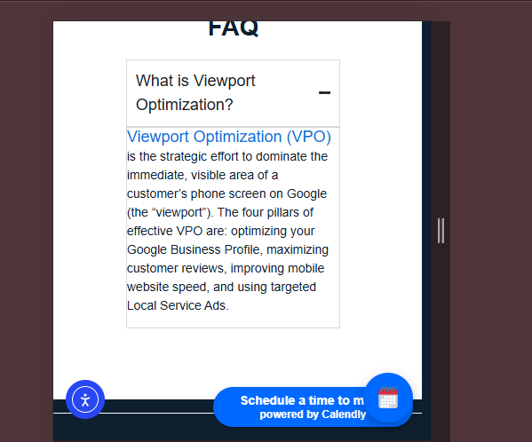

On Mobile, text seems to be hidden behind due to being overlapped by the calendar icon

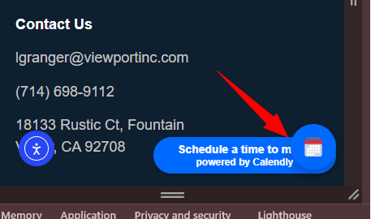

The Footer needs to have padding underneath

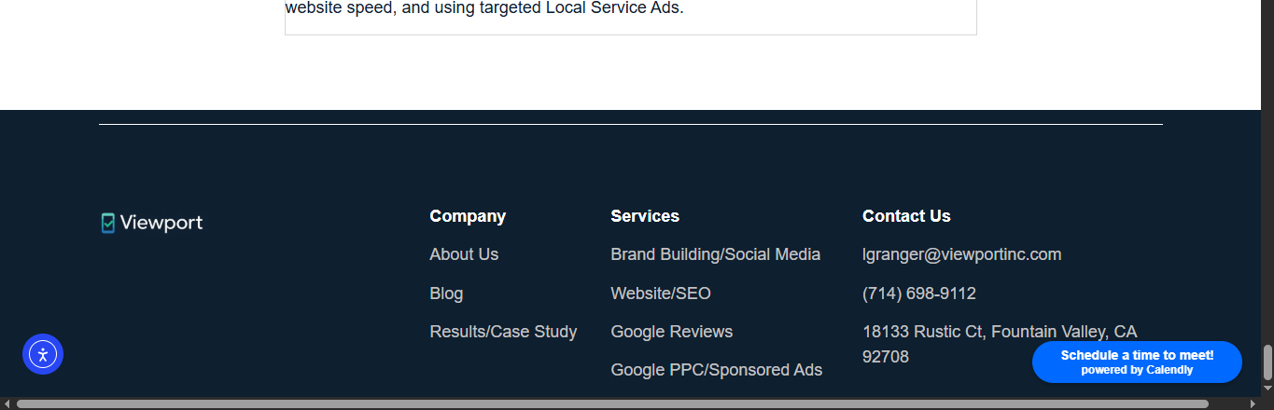

On Mobile, there are unusual spacing above and underneath the logo in footer

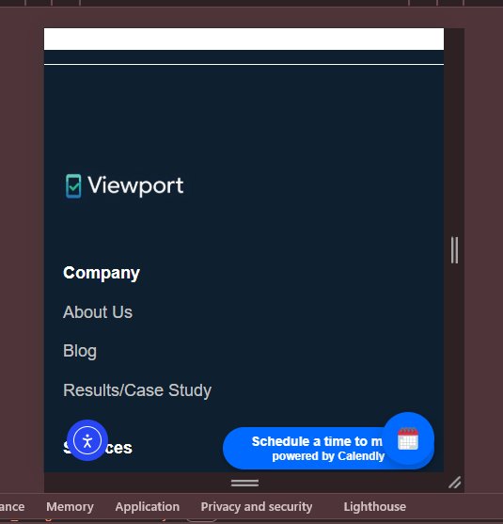

**Contact Us Page**

Let’s reduce the vertical space underneath the title in the hero section of Contact Us Page. (The same practice will be also applied for the mobile)

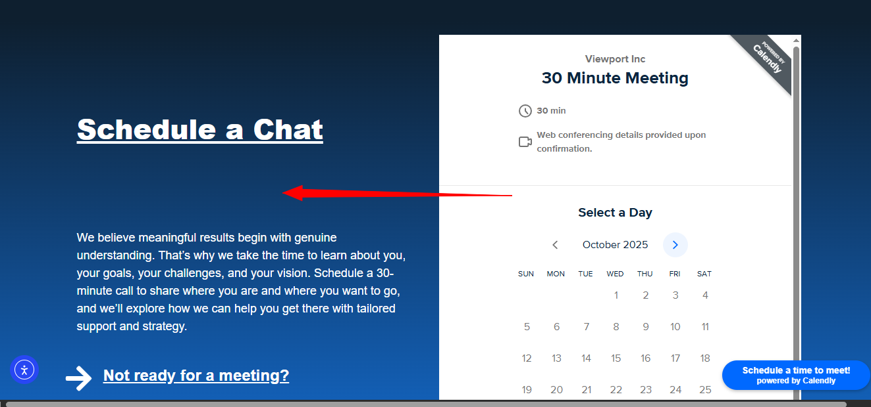

On Mobile let’s resolve the following issues:  
1) Either all text would be centerline in the hero section or left align (centerline is recommended as per site mobile consistency)  
2) Excessive vertical spacing needs to be reduced  
3) The Arrow icon size is pretty big  
4. The Arrow icon is not horizontally aligned with the text

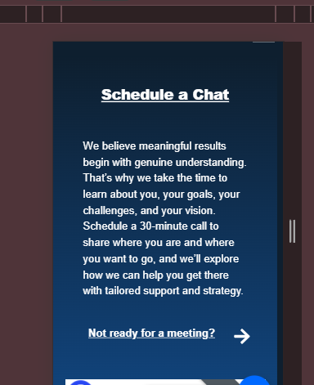

The Successful message will be centered in alignment

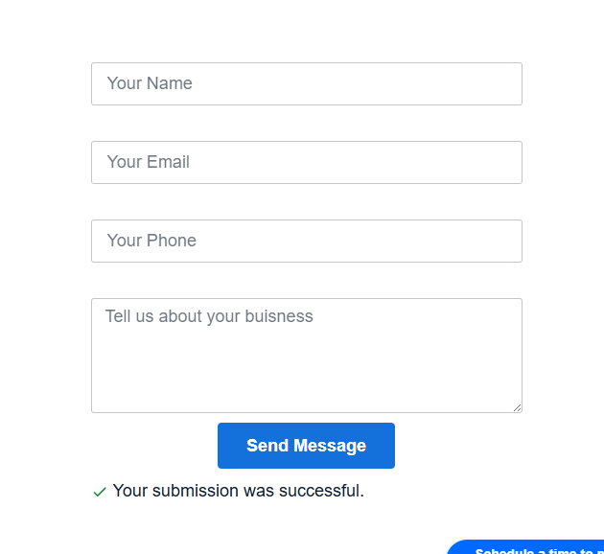

The icon seems pretty much bigger (might also need to reduce the font-size) when normalizing the icon sizes



**Results Page**

The following issues needs to be resolved:  
1) On Desktop screens, (1024px to 1920px): the cards width needs to be increased till container so that the text can be aligned horizontally instead of stacked vertically as they are now  
2) There’s a need to add vertical space between the cards and the “blue” CTA

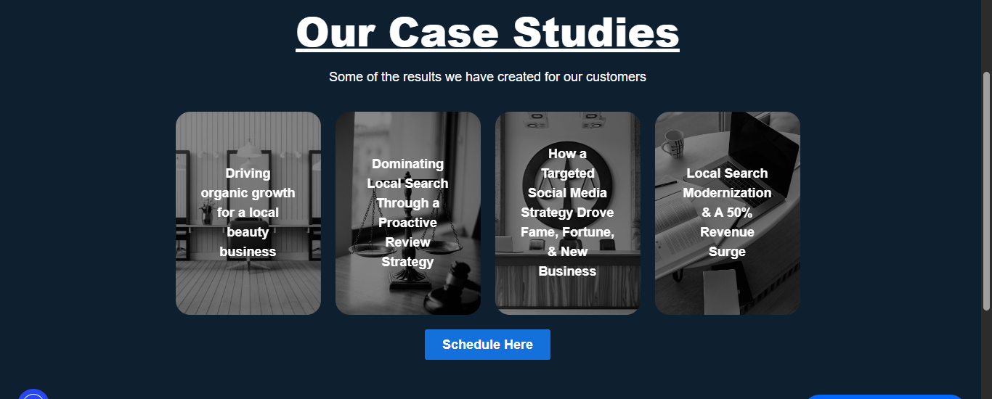

Let’s reduced the underneath padding on both desktop and mobile screens



**About Us Page**

The About Us hero section size needs to be reduced (Spacing from top and bottom) as it is not coming in first viewport. This must always be addressed on the mobile side

**(Note: “Hero Section of other pages are usually smaller in height than homepage and are of equal heights”)**



The following stuff needs to be fixed on mobile: First of all, the heading is not horizontally centered, Similarly the “Blue leaf icon” is not vertically centered with the text and finally there are vertical spacing which needs to be reduced and normalized

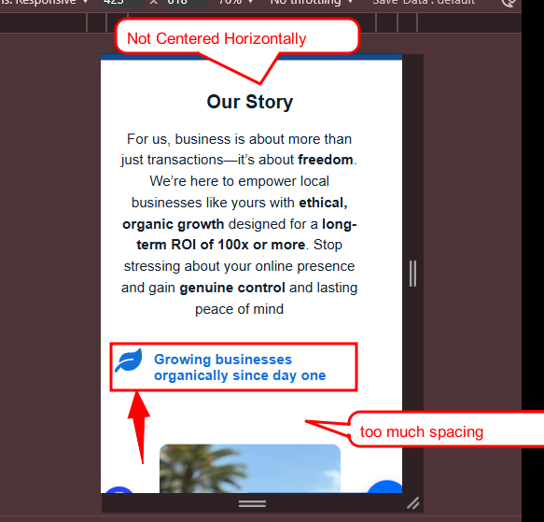

There is too much vertical spacing between the cards making the section more vertically longer on mobile view (**Suggestion:** Adding extra padding from top and bottom to cover the spacing can also be a cherry on top)

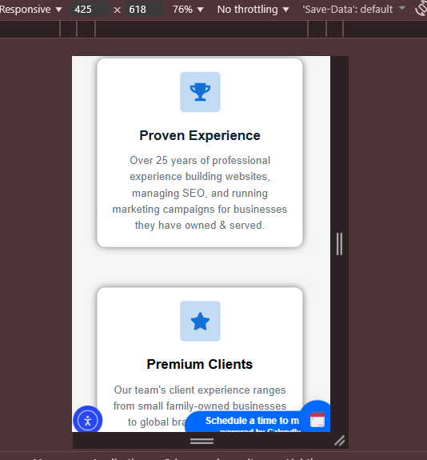

The Vertical spacing on mobile needs to be removed along with aligning the four icons along with their texts



Similarly, the vertical spacing on desktop will also be adjusted



The vertical space underneath the picture might need to be reduced

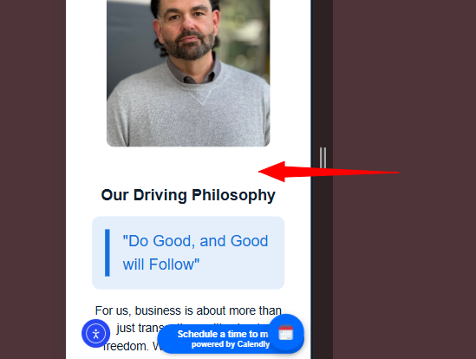

The Vertical Spacing underneath the title and underneath the sub-text needs to be reduced  
(The same thing also applies for mobile)



**Services / Brand Building Social Media Page**

On Hero Section, the vertical spacing underneath the heading + b/w the Sub-text and CTA are pretty much high.



On Small screens such fr0m 768px to 1440px, the left side section can be a sticky scroller

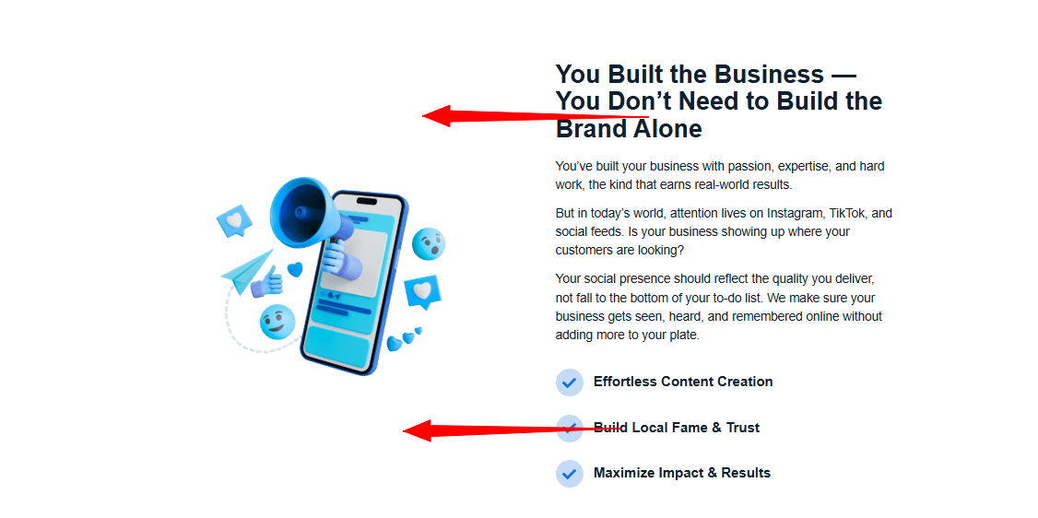

On Mobile, the vertical distance b/w each point needs to be reduced. (+ the tick icon sizes can also be reduced following site overall consistency)

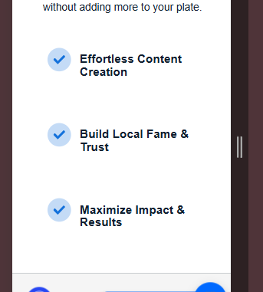

On Mobile, spacing under the heading + in the end of the section seems way more, while the spacing between each “Textual point” needs to be increased a little bit

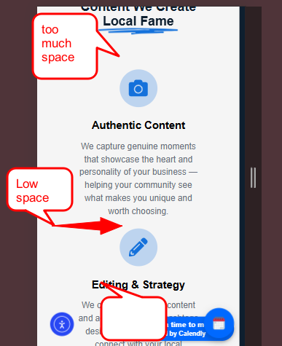

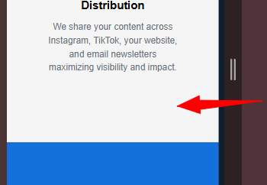

The Vertical Spacing underneath the title and underneath the sub-text needs to be reduced  
(The same thing also applies for mobile)

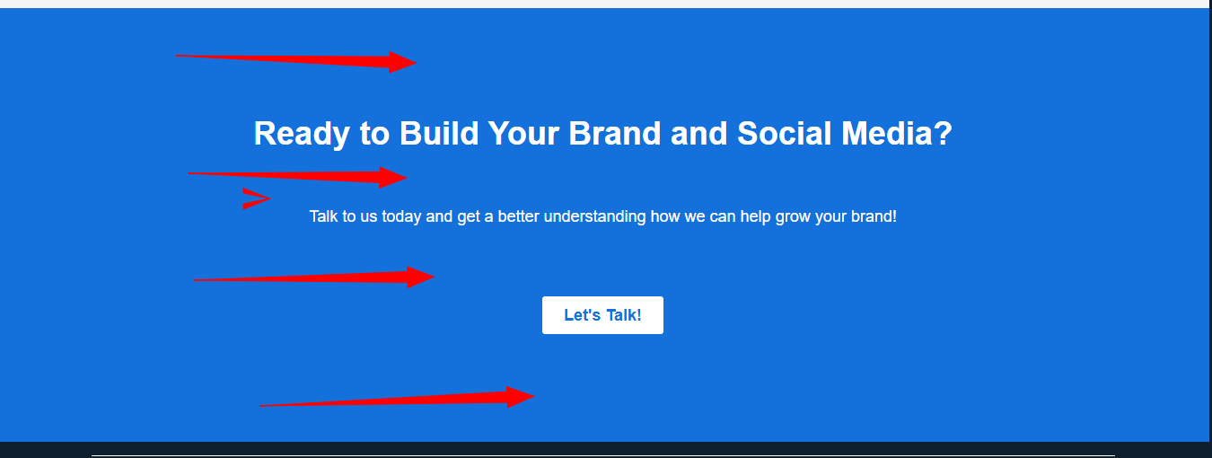

**Services / Website Design & SEO Page**

On Hero Section, the vertical spacing underneath the heading + b/w the Sub-text and CTA are pretty much high.



On Mobile, the vertical spacing underneath the picture can be reduced



* The Alignment of heading should also match the alignment of sub-text (which is: left align)
* To prevent the white space above and below the left portion of the section, we can indeed make the left part of the section sticky (from 768px onwards)

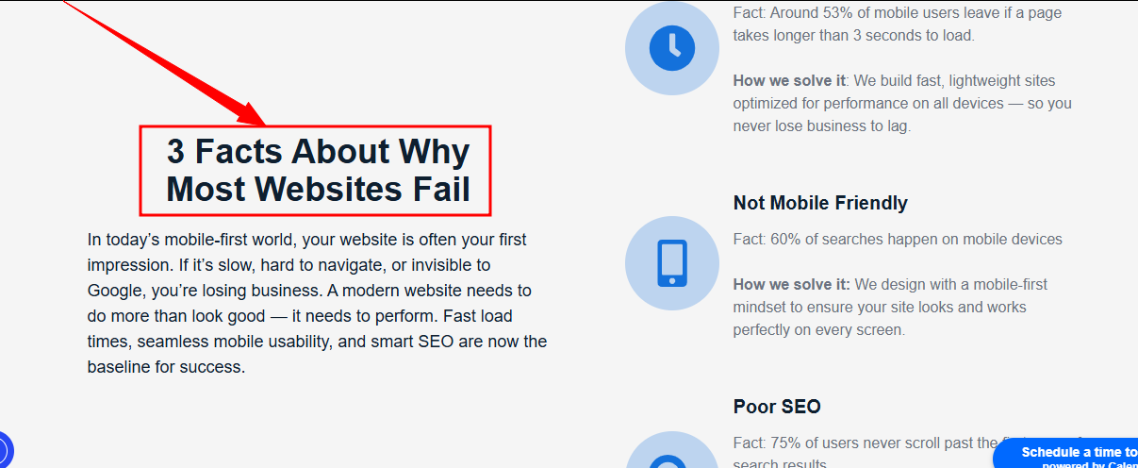

Pretty much spacing here on mobile, there is a need to normalize it

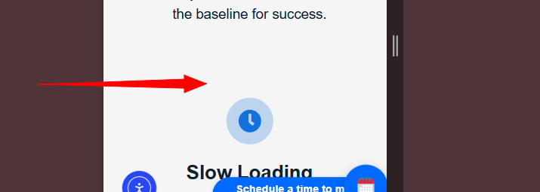

Horizontal and vertical spacing b/w the cards can be improved / reduced. (Similarly on Mobile as well)

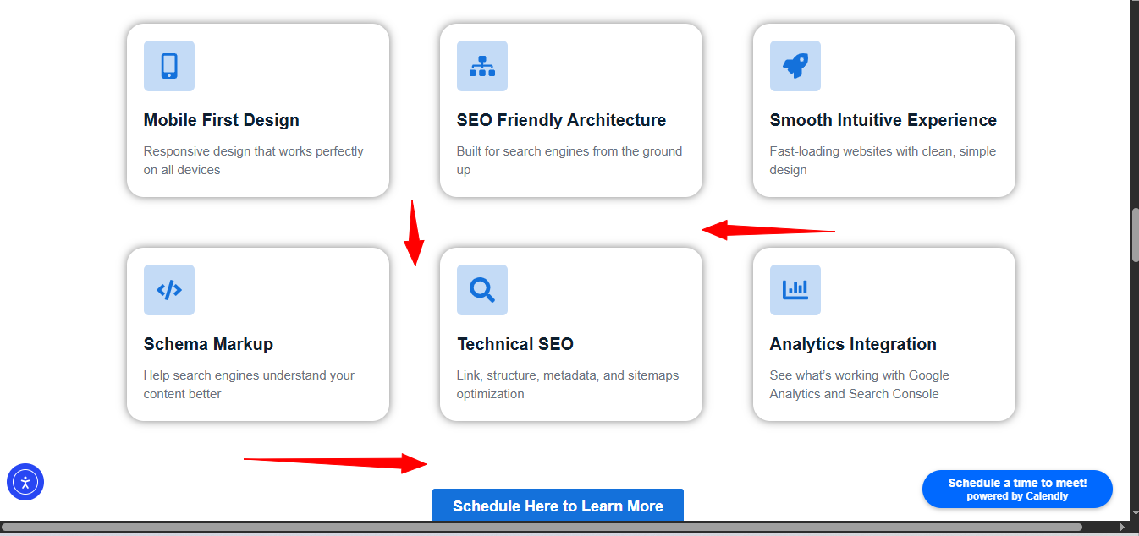

On Mobile, padding of this blue block from all sides should be equal



On Mobile, Vertical spacing b/w the cards and above the CTA needs to be reduced (so that section does not exceeds the vertical length on mobile)

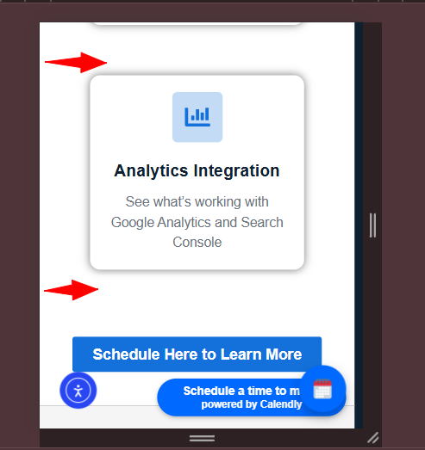

* Let’s make sizes of arrows and text consistent
* The First arrow icon should not be vertically centerline (with the reference to the text on it’s right)

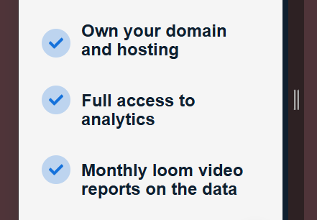

The padding of the card from bottom needs to be reduced

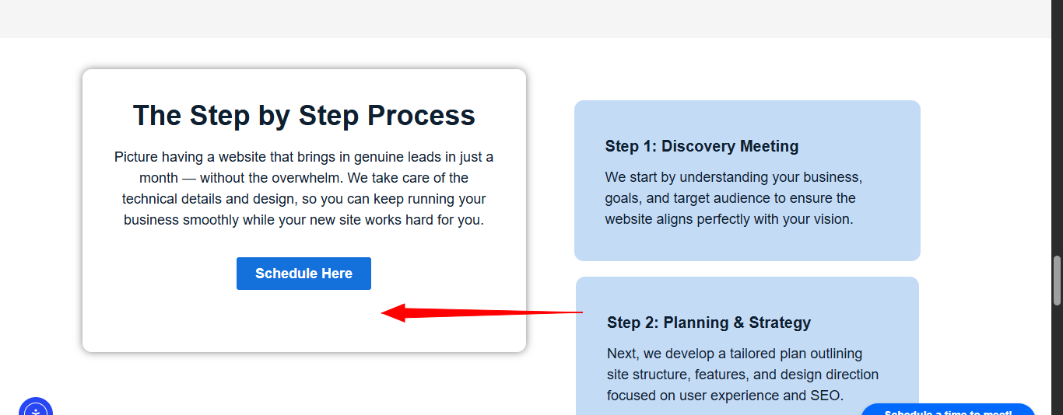

On Mobile, Let’s remove the stickiness of the top card so that it does not collide with the other cards.

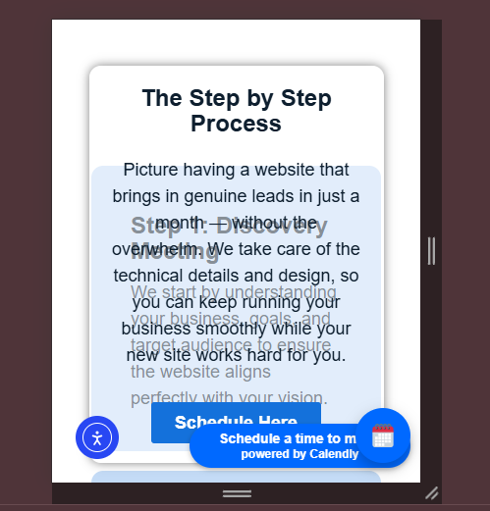

The bottom of the last card needs to have spaced so that it does not overlaps with the blue section underneath it.

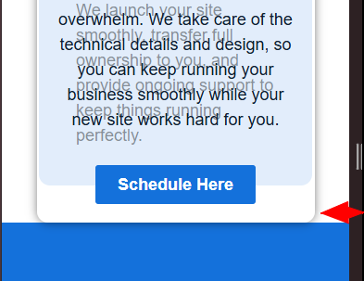

The Vertical Spacing underneath the title and underneath the sub-text needs to be reduced  
**(The same thing also applies for mobile)**



**Services / Google History Page**

On Hero Section, the vertical spacing underneath the heading + b/w the Sub-text and CTA are pretty much high. (Same thing must be applied on mobile as well)



Either Heading must be centerline or sub-text must be left aligned to have a consistency



Let’s reduce the vertical spacing on mobile



On Mobile, there are vertical spacing issues

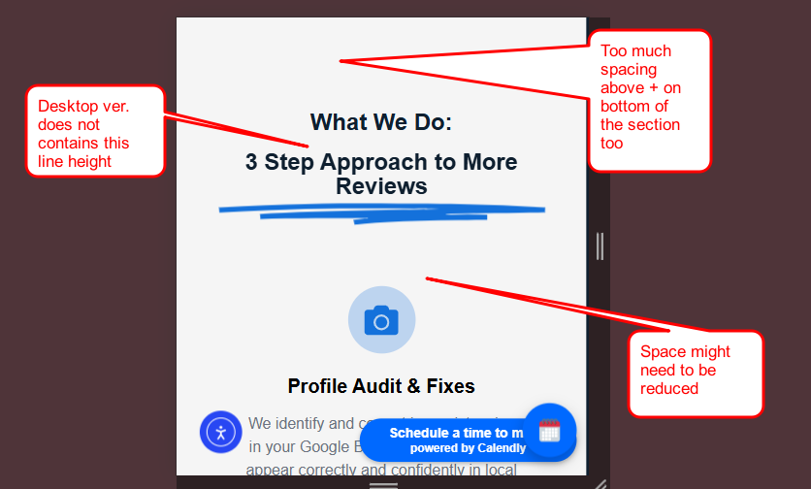

On Mobile, there are vertical spacing between the “bullet points” (The Arrow icon sizes must be normalized too considering current site consistency)

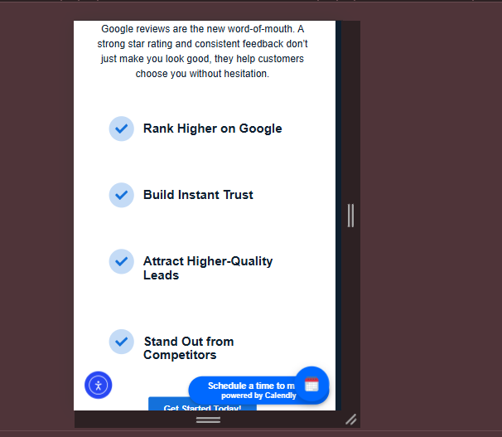

The Vertical Spacing underneath the title and underneath the sub-text needs to be reduced  
**(The same thing also applies for mobile)**



**Services / Google PPC Page**The heading should be also be justified center or sub-text should be justified left

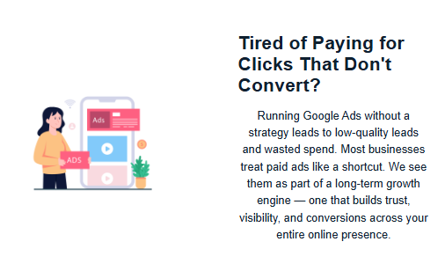

On Mobile, the space under the image needs to be reduced

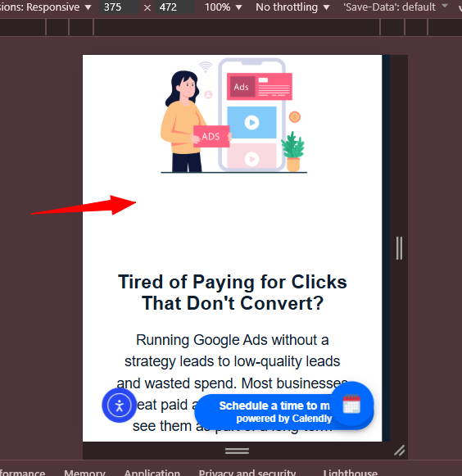

On Mobile, there are vertical spacing between the “bullet points” (The Arrow icon sizes must be normalized too considering current site consistency)



The vertical spacing on the bottom of the section + between each points needs to be increased

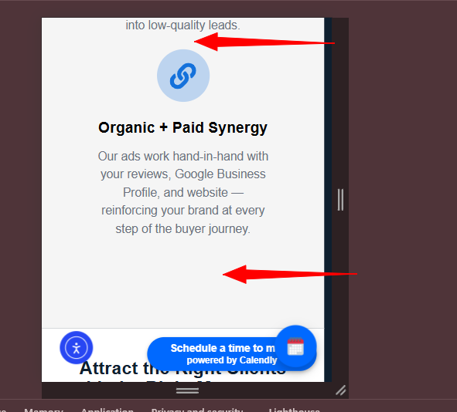

The Vertical Spacing underneath the title and underneath the sub-text needs to be reduced  
**(The same thing also applies for mobile)**

